"Обновление ClamAV" (https://jira.tcsbank.ru/browse/IN-1048) [Петрова Юлия]
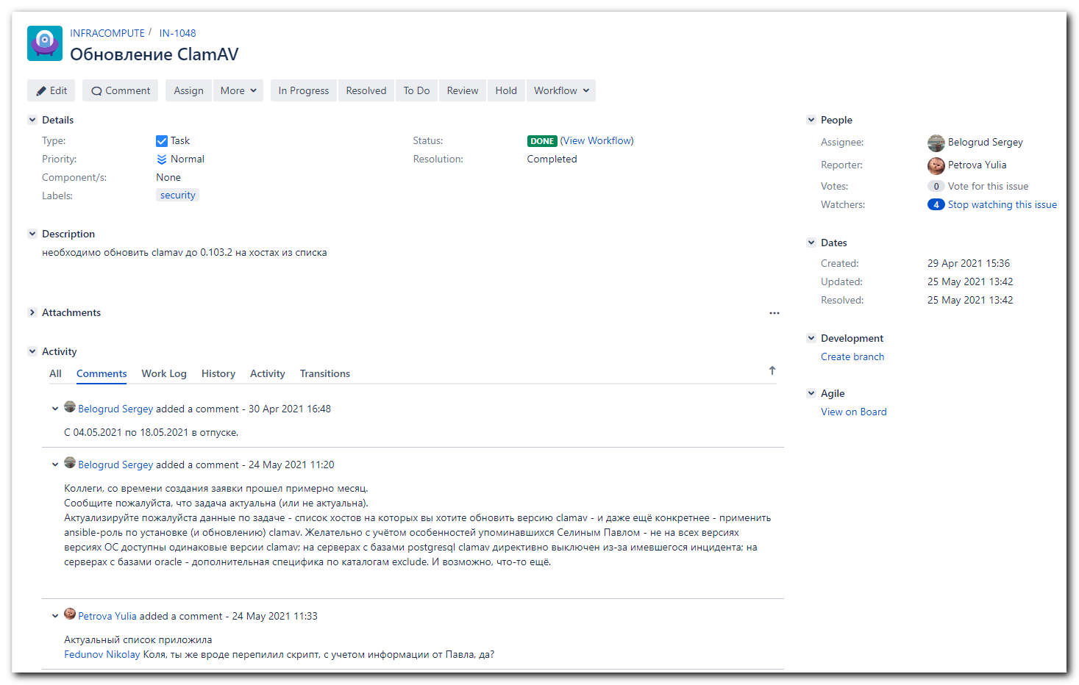

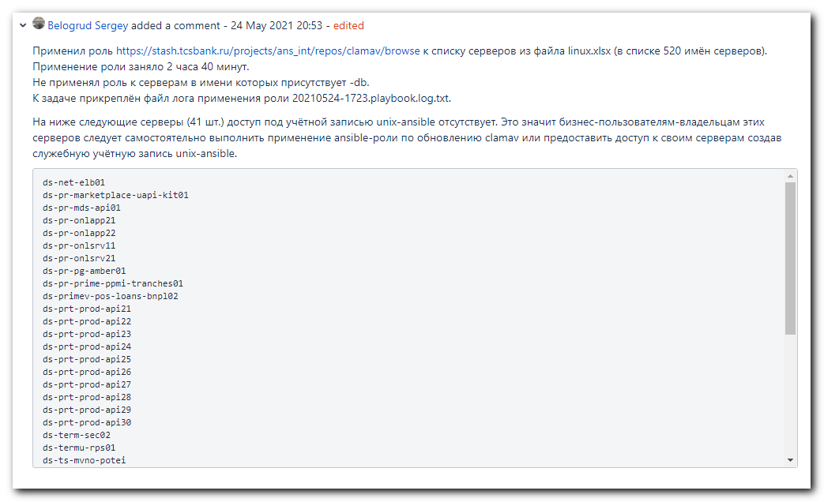
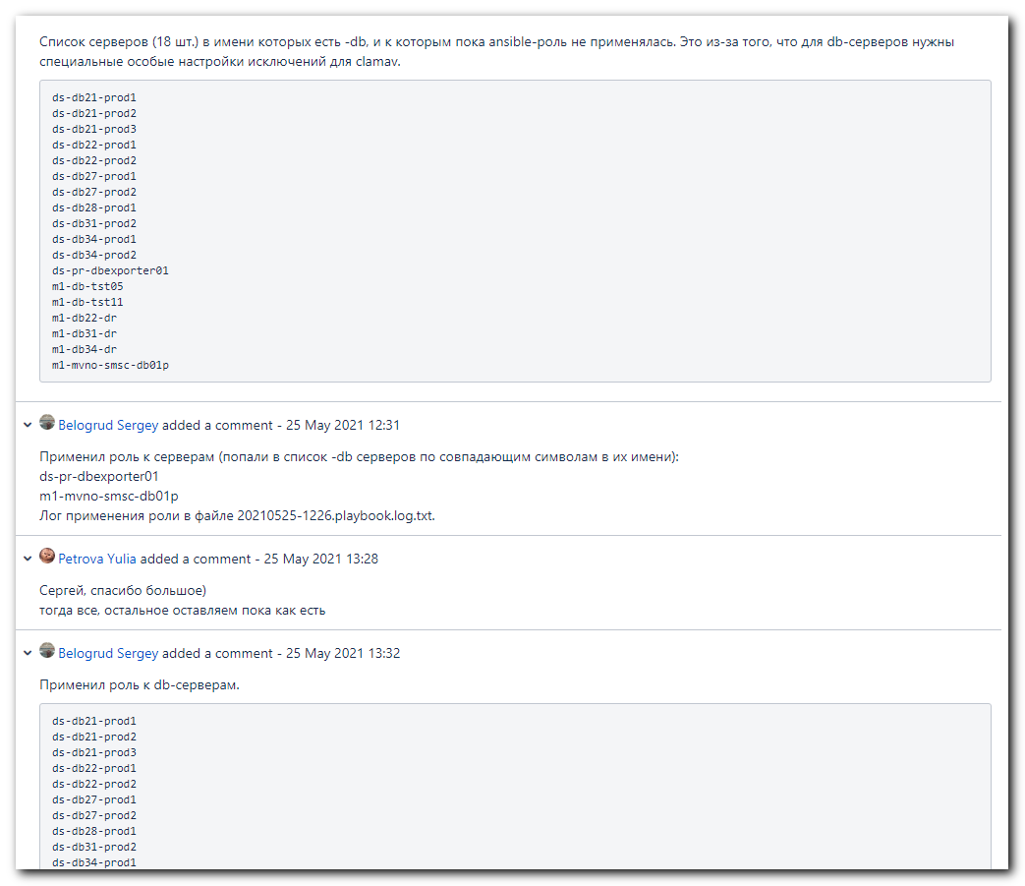
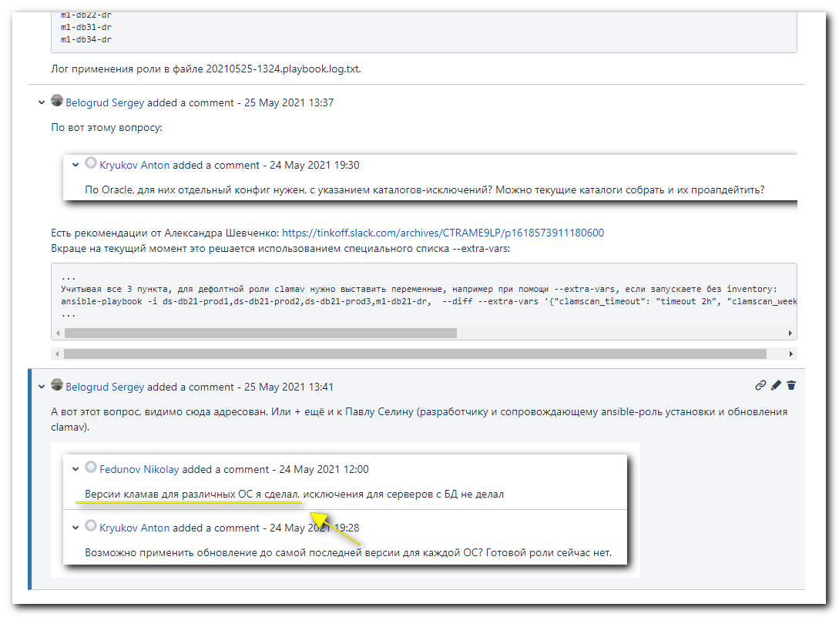

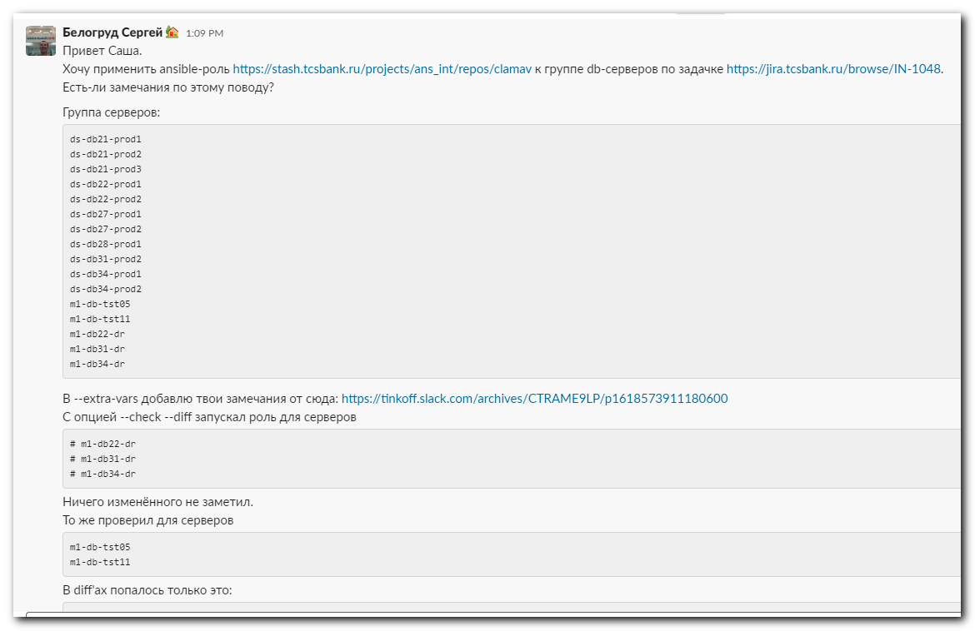
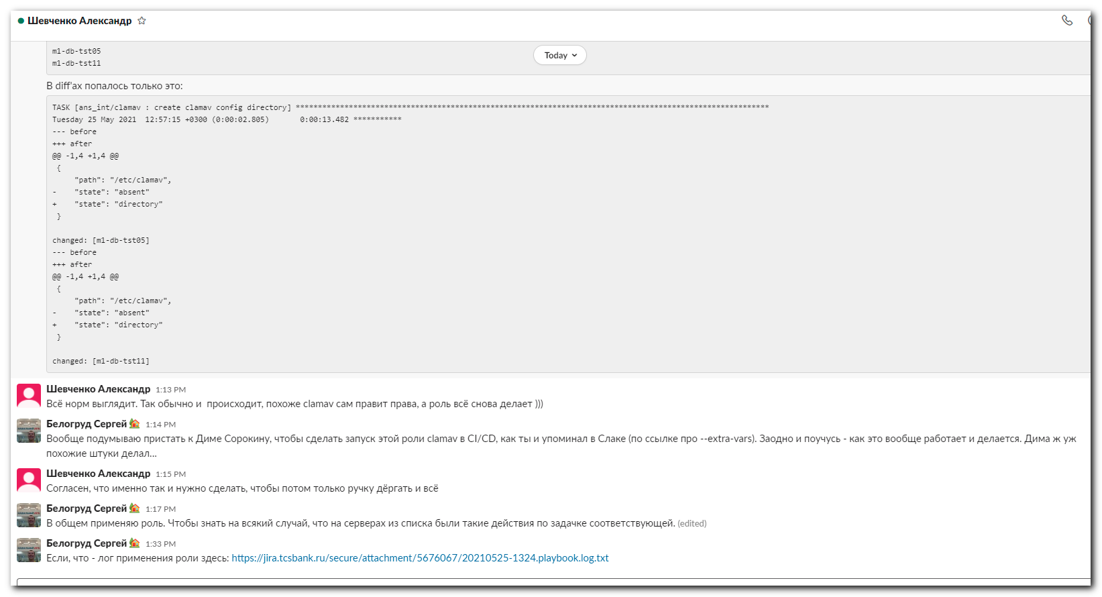

#
# I used follow file, that was attached to the task.
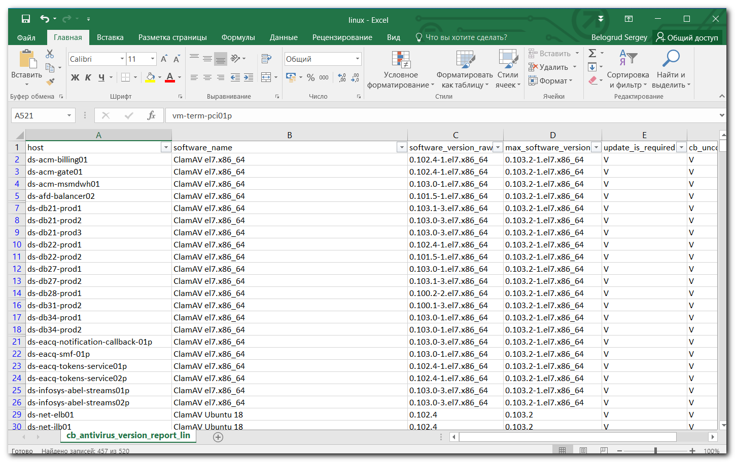

# Here is a filter to get all servers, exclude Oracle db-servers.
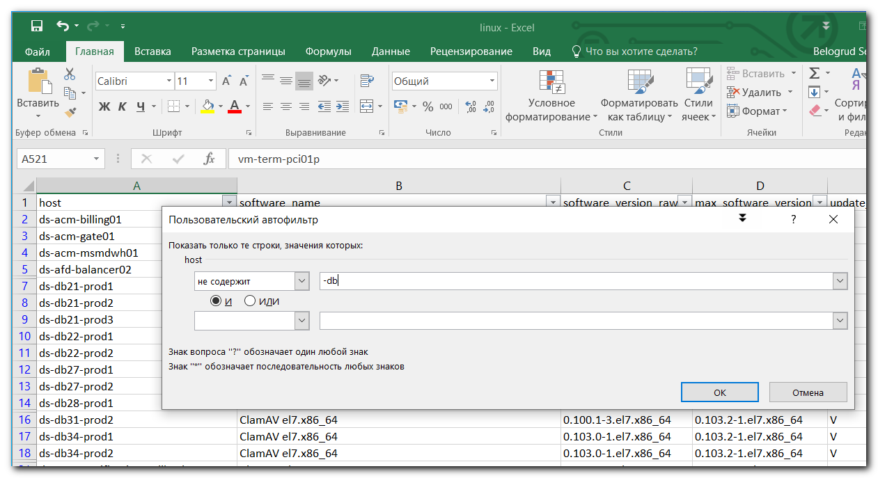

# Here is a filter to get only Oracle db-servers.
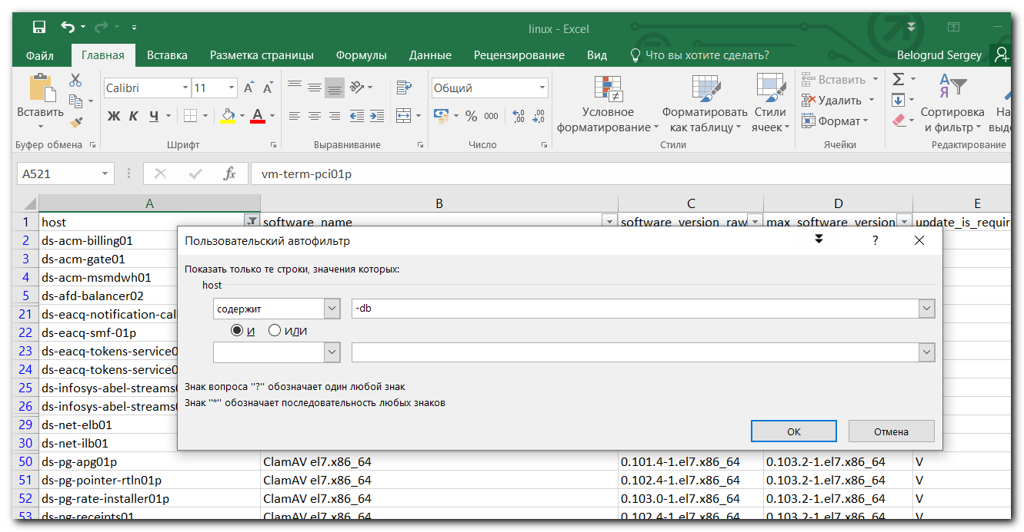

# But two servers are not belonged to db-serves.
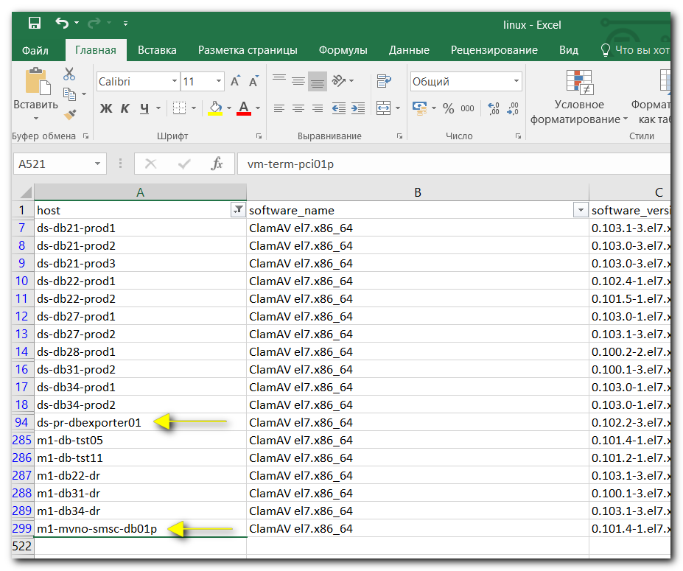

#
# I turned on creation .retry file, to easy get list of UNREACHABLE hosts.
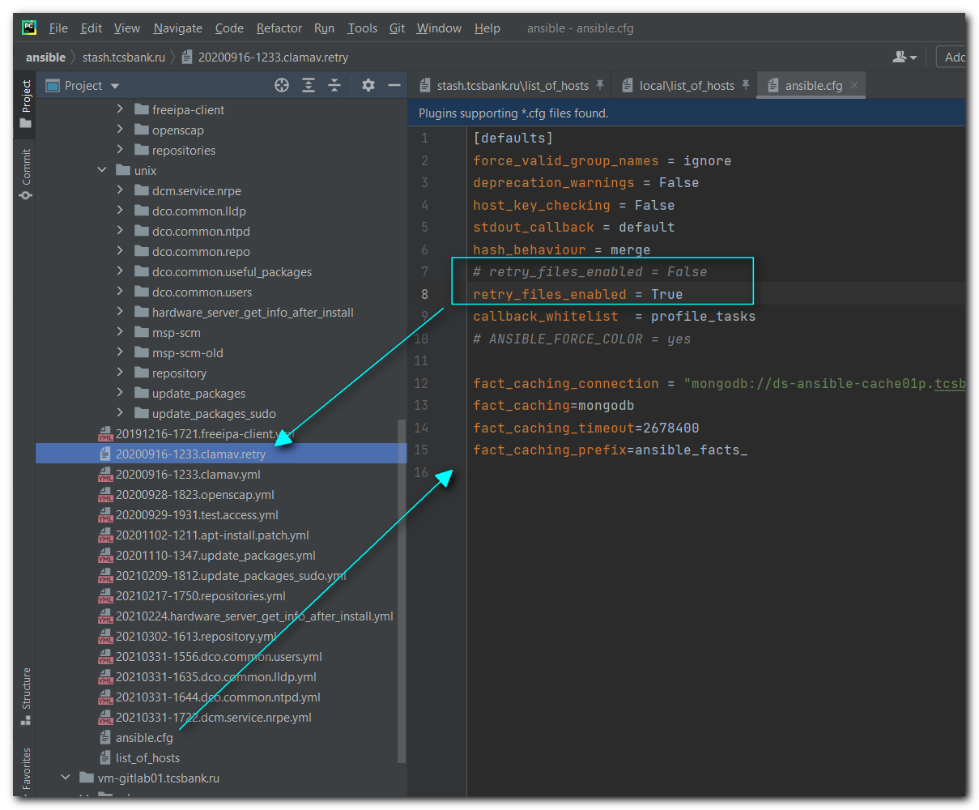

#
# Here is a command I used to apply ansible role clamav.
# For ~500 servers this task took 2 hours 40 minutes, when I executed it from my WSL Ubuntu 20.04.
#
[support@nb2339]# export ANSIBLE_CONFIG=ansible.cfg ; logfile="$(date +%Y%m%d-%H%M).playbook.log.txt" ; ansible-playbook 20200916-1233.clamav.yml -i list_of_hosts --become --extra-vars "ansible_user=unix-ansible ansible_password=$(pass common/linux-unix-ansible) ansible_sudo_pass=$(pass common/linux-unix-ansible) ansible_ssh_common_args='-oStrictHostKeyChecking=no -oPubkeyAuthentication=no -oUserKnownHostsFile=/dev/null'" -f 15 | tee -a ./output/${logfile}

ds-acm-billing01
ds-acm-gate01
ds-acm-msmdwh01
ds-afd-balancer02
ds-eacq-notification-callback-01p
ds-eacq-smf-01p
ds-eacq-tokens-service01p
ds-eacq-tokens-service02p
ds-infosys-abel-streams01p
ds-infosys-abel-streams02p
ds-net-elb01
ds-net-ilb01
ds-pg-apg01p
ds-pg-pointer-rtln01p
ds-pg-rate-installer01p
ds-pg-receipts01
ds-pg-receipts02
ds-pg-rls-adapter-sberfix01p
ds-pg-rls-adapter-sberfix02p
ds-pg-sbp-router01
ds-pg-sme02
ds-postgresql416p
ds-postgresql45p
ds-pr-acq-bms-ui01p
ds-pr-acq-lb-ext01p
ds-pr-acq-lb-ext02p
ds-pr-acq-lb02p
ds-pr-acq-notification01
ds-pr-acq-posapi01p
ds-pr-acq-reciept02p
ds-pr-acqapi01p
ds-pr-acqapi03p
ds-pr-acqapi04p
ds-pr-acs02
ds-pr-afd-prod02
ds-pr-apsv-backend01
ds-pr-apsv-frontend01
ds-pr-apsv-rabbit01
ds-pr-atmapi-kafka-rest01
ds-pr-atmapi-lb01
ds-pr-atmapi-lb02
ds-pr-atmapi01p
ds-pr-atmapi02p
ds-pr-atmapi03p
ds-pr-atmapi04p
ds-pr-atmapi05p
ds-pr-atmapi06p
ds-pr-atmapi07p
ds-pr-atmapi08p
ds-pr-atmapi09p
ds-pr-atmapi10p
ds-pr-awx01
ds-pr-bliss01
ds-pr-bliss02
ds-pr-dtswapper01
ds-pr-dtswapper02
ds-pr-eacq-einv01p
ds-pr-eacq-epay01p
ds-pr-eacq-mapi-pf01p
ds-pr-eacq-mapi-pf02p
ds-pr-eacq-mapi01p
ds-pr-eacq-mapi02p
ds-pr-eacq-mapi03p
ds-pr-eacq-pfie01p
ds-pr-eacq-sbpadapt01p
ds-pr-eacq-tdss01p
ds-pr-hsmapi01
ds-pr-hsmapi02
ds-pr-ignite03
ds-pr-ignite04
ds-pr-infra-lb01
ds-pr-ips-lb-ext01p
ds-pr-ips-lb01p
ds-pr-marketplace-uapi-emul01
ds-pr-marketplace-uapi-ext01
ds-pr-marketplace-uapi-goods-01
ds-pr-marketplace-uapi-kit01
ds-pr-mds-api01
ds-pr-mds-api02
ds-pr-mds-api03
ds-pr-mds-api04
ds-pr-mta01
ds-pr-onlapp11
ds-pr-onlapp12
ds-pr-onlapp21
ds-pr-onlapp22
ds-pr-onlsrv11
ds-pr-onlsrv21
ds-pr-ops01
ds-pr-ops02
ds-pr-ops03
ds-pr-ops04
ds-pr-ops05
ds-pr-ops06
ds-pr-paym-dsw-logstash01
ds-pr-paym-error-logstash01
ds-pr-paym-es-i-01
ds-pr-paym-es-i-02
ds-pr-paym-static-01p
ds-pr-pg-aggregator-gate01
ds-pr-pg-amber01
ds-pr-pg-antifraud01
ds-pr-pg-cache-warmup01p
ds-pr-pg-check01
ds-pr-pg-fee01
ds-pr-pg-fee02
ds-pr-pg-finline-external01p
ds-pr-pg-lb01
ds-pr-pg-lb02
ds-pr-pg-lcs02
ds-pr-pg-lcs03
ds-pr-pg-lcs04
ds-pr-pg-paymentcancel01
ds-pr-pg-pointer-sbp01
ds-pr-pg-pointer-sbp02
ds-pr-pg-pointer01
ds-pr-pg-pointer02
ds-pr-pg-pointer03
ds-pr-pg-prv01
ds-pr-pg-qr01p
ds-pr-pg-rate-controller01p
ds-pr-pg-regular01p
ds-pr-pg-rosneft01
ds-pr-pg01p
ds-pr-pg02p
ds-pr-pg03p
ds-pr-pg04p
ds-pr-pg05p
ds-pr-pg06p
ds-pr-pg07p
ds-pr-pg08p
ds-pr-pplb-ext-01
ds-pr-pplb-ext-02
ds-pr-prime-imdg-zk01
ds-pr-prime-jazz01
ds-pr-prime-loyalty-partners01
ds-pr-prime-loyalty01
ds-pr-prime-loyalty02
ds-pr-prime-megatron01
ds-pr-prime-megatron02
ds-pr-prime-megatron03
ds-pr-prime-options01
ds-pr-prime-ppcc02
ds-pr-prime-pple-jobs01
ds-pr-prime-pple01
ds-pr-prime-ppmi-tranches01
ds-pr-prime-ppmi-tranches02
ds-pr-primev-info-bpm-01
ds-pr-primev-info-bpm-02
ds-pr-primev-info-mobile01
ds-pr-primev-info-mobile02
ds-pr-prm-ext-lb01
ds-pr-prm-ext-lb02
ds-pr-psilogstash01
ds-pr-psilogstash02
ds-pr-qrpay02p
ds-pr-sentry-rbmq01
ds-pr-sentry-redis01
ds-pr-sentry02
ds-pr-sexi-02
ds-pr-smog-web-1
ds-pr-smog02
ds-pr-sp-invest-01
ds-pr-sp-invest-02
ds-pr-tinkoff-bundle01
ds-pr-tinkoff-bundle02
ds-pr-tms01p
ds-primev-pos-loans-bnpl02
ds-prm-fm-front01
ds-prm-front01
ds-prm-sso01
ds-prm-tm-front01
ds-prt-prod-api01
ds-prt-prod-api02
ds-prt-prod-api03
ds-prt-prod-api04
ds-prt-prod-api05
ds-prt-prod-api06
ds-prt-prod-api07
ds-prt-prod-api08
ds-prt-prod-api09
ds-prt-prod-api10
ds-prt-prod-api11
ds-prt-prod-api12
ds-prt-prod-api13
ds-prt-prod-api14
ds-prt-prod-api15
ds-prt-prod-api16
ds-prt-prod-api17
ds-prt-prod-api18
ds-prt-prod-api19
ds-prt-prod-api20
ds-prt-prod-api21
ds-prt-prod-api22
ds-prt-prod-api23
ds-prt-prod-api24
ds-prt-prod-api25
ds-prt-prod-api26
ds-prt-prod-api27
ds-prt-prod-api28
ds-prt-prod-api29
ds-prt-prod-api30
ds-prt-prod-api31
ds-prt-prod-api32
ds-prt-prod-api33
ds-prt-prod-api34
ds-prt-prod-api35
ds-prt-prod-api36
ds-prt-prod-api37
ds-prt-prod-api38
ds-prt-prod-api39
ds-prt-prod-api40
ds-prt-prod-api41
ds-prt-prod-api42
ds-prt-prod-api43
ds-prt-prod-api44
ds-prt-prod-api45
ds-prt-prod-api46
ds-prt-prod-api47
ds-prt-prod-api48
ds-prt-prod-api49
ds-prt-prod-api50
ds-secstorage01p
ds-softcase-hub01p
ds-term-ext-net01
ds-term-sec02
ds-termu-rps01
ds-ts-mvno-potei
m1-acm-billing01
m1-acm-gate01
m1-acm-msmdwh01
m1-eacq-notification-callback-01p
m1-eacq-smf-01p
m1-eacq-tokens-service01p
m1-eacq-tokens-service02p
m1-infosys-abel-streams01p
m1-infosys-abel-streams02p
m1-mvno-ts-tapi01
m1-net-elb01
m1-net-ilb01
m1-pg-apg01p
m1-pg-pointer-rtln01p
m1-pg-rate-installer01p
m1-pg-receipts01
m1-pg-receipts02
m1-pg-rls-adapter-bloomberg01
m1-pg-sbp-router01
m1-pg-sme02
m1-postgresql45p
m1-pr-acm2-clearing02p
m1-pr-acq-bms-ui01p
m1-pr-acq-lb-ext01p
m1-pr-acq-lb-ext02p
m1-pr-acq-lb02p
m1-pr-acq-posapi01p
m1-pr-acq-reciept02p
m1-pr-acqapi01p
m1-pr-acqapi03p
m1-pr-acqapi04p
m1-pr-acs02
m1-pr-afd-prod03
m1-pr-apsv-backend01
m1-pr-apsv-frontend01
m1-pr-apsv-rabbit01
m1-pr-atmapi-lb01
m1-pr-atmapi-lb02
m1-pr-atmapi01p
m1-pr-atmapi02p
m1-pr-atmapi03p
m1-pr-atmapi04p
m1-pr-atmapi05p
m1-pr-atmapi06p
m1-pr-atmapi07p
m1-pr-atmapi08p
m1-pr-atmapi09p
m1-pr-atmapi10p
m1-pr-bliss01
m1-pr-dtswapper01
m1-pr-dtswapper02
m1-pr-eacq-einv01p
m1-pr-eacq-fms-01p
m1-pr-eacq-mapi-pf01p
m1-pr-eacq-mapi-pf02p
m1-pr-eacq-mapi01p
m1-pr-eacq-mapi02p
m1-pr-eacq-mapi03p
m1-pr-eacq-pfapi01p
m1-pr-eacq-pfie01p
m1-pr-eacq-sbpadapt01p
m1-pr-eacq-tdss01p
m1-pr-ips-lb-ext01p
m1-pr-ips-lb01p
m1-pr-lb02
m1-pr-marketplace-uapi-goods-01
m1-pr-marketplace-uapi-kit01
m1-pr-mds-api01
m1-pr-mds-api02
m1-pr-mds-api03
m1-pr-mds-api04
m1-pr-mta01
m1-pr-onlapp11
m1-pr-onlapp12
m1-pr-onlsrv11
m1-pr-ops01
m1-pr-ops02
m1-pr-ops03
m1-pr-ops04
m1-pr-ops05
m1-pr-ops06
m1-pr-paym-error-logstash01
m1-pr-pg-aggregator-gate01
m1-pr-pg-amber01
m1-pr-pg-antifraud01
m1-pr-pg-check01
m1-pr-pg-fee01
m1-pr-pg-fee02
m1-pr-pg-finline-external01p
m1-pr-pg-ignite-1
m1-pr-pg-ignite-2
m1-pr-pg-ignite-4
m1-pr-pg-ignite-5
m1-pr-pg-lb01
m1-pr-pg-lb02
m1-pr-pg-lcs02
m1-pr-pg-paymentcancel01
m1-pr-pg-pointer-sbp01
m1-pr-pg-pointer-sbp02
m1-pr-pg-pointer01
m1-pr-pg-pointer02
m1-pr-pg-pointer03
m1-pr-pg-prv01
m1-pr-pg-qr01p
m1-pr-pg-rate-controller01p
m1-pr-pg-regular01p
m1-pr-pg-rosneft01
m1-pr-pg01p
m1-pr-pg02p
m1-pr-pg03p
m1-pr-pg04p
m1-pr-pg05p
m1-pr-pg06p
m1-pr-pg07p
m1-pr-pg08p
m1-pr-pplb-ext-01
m1-pr-pplb-ext-02
m1-pr-prime-imdg-zk01
m1-pr-prime-imdg-zk02
m1-pr-prime-jazz01
m1-pr-prime-loyalty-partners01
m1-pr-prime-loyalty01
m1-pr-prime-loyalty02
m1-pr-prime-megatron01
m1-pr-prime-megatron02
m1-pr-prime-megatron03
m1-pr-prime-options01
m1-pr-prime-ppgi03
m1-pr-prime-pple-jobs01
m1-pr-prime-pple01
m1-pr-prime-ppmi-tranches01
m1-pr-prime-ppmi-tranches02
m1-pr-primev-info-bpm-01
m1-pr-primev-info-bpm-02
m1-pr-primev-info-mobile01
m1-pr-primev-info-mobile02
m1-pr-prm-api01
m1-pr-prm-ext-lb01
m1-pr-prm-ext-lb02
m1-pr-psilogstash01
m1-pr-qrpay02p
m1-pr-sexi-02
m1-pr-smog-web-1
m1-pr-smog02
m1-pr-sp-invest-01
m1-pr-tinkoff-bundle01
m1-pr-tms01p
m1-primev-pos-loans-bnpl02
m1-prm-fm-front01
m1-prm-front01
m1-prm-sso01
m1-prod-payments-napp-2
m1-prt-prod-api01
m1-prt-prod-api02
m1-prt-prod-api03
m1-prt-prod-api04
m1-prt-prod-api05
m1-prt-prod-api06
m1-prt-prod-api07
m1-prt-prod-api08
m1-prt-prod-api09
m1-prt-prod-api10
m1-prt-prod-api11
m1-prt-prod-api12
m1-prt-prod-api13
m1-prt-prod-api14
m1-prt-prod-api15
m1-prt-prod-api16
m1-prt-prod-api17
m1-prt-prod-api18
m1-prt-prod-api19
m1-prt-prod-api20
m1-prt-prod-api21
m1-prt-prod-api22
m1-prt-prod-api23
m1-prt-prod-api24
m1-prt-prod-api25
m1-prt-prod-api26
m1-prt-prod-api27
m1-prt-prod-api28
m1-prt-prod-api29
m1-prt-prod-api30
m1-prt-prod-api31
m1-prt-prod-api32
m1-prt-prod-api33
m1-prt-prod-api34
m1-prt-prod-api35
m1-prt-prod-api36
m1-prt-prod-api37
m1-prt-prod-api38
m1-prt-prod-api39
m1-prt-prod-api40
m1-prt-prod-api41
m1-prt-prod-api42
m1-prt-prod-api43
m1-prt-prod-api44
m1-prt-prod-api45
m1-prt-prod-api46
m1-prt-prod-api47
m1-prt-prod-api48
m1-prt-prod-api49
m1-prt-prod-api50
m1-receipts-prod-web-stand-1
m1-sirena-travel-1
m1-ts-mvno-nfware
vm-pr-atm-deploy1
vm-pr-atm-zabbix01p
vm-pr-cp-atmapi01p
vm-secstorage01
vm-softcase-hub03
vm-term-pci01p

# List of servers, which name has "-db" symbols.
ds-db21-prod1
ds-db21-prod2
ds-db21-prod3
ds-db22-prod1
ds-db22-prod2
ds-db27-prod1
ds-db27-prod2
ds-db28-prod1
ds-db31-prod2
ds-db34-prod1
ds-db34-prod2
ds-pr-dbexporter01
m1-db-tst05
m1-db-tst11
m1-db22-dr
m1-db31-dr
m1-db34-dr
m1-mvno-smsc-db01p

#
# Access is absent to follow servers.
# 20200916-1233.clamav.retry
#
ds-net-elb01
ds-pr-marketplace-uapi-kit01
ds-pr-mds-api01
ds-pr-onlapp21
ds-pr-onlapp22
ds-pr-onlsrv11
ds-pr-onlsrv21
ds-pr-pg-amber01
ds-pr-prime-ppmi-tranches01
ds-primev-pos-loans-bnpl02
ds-prt-prod-api21
ds-prt-prod-api22
ds-prt-prod-api23
ds-prt-prod-api24
ds-prt-prod-api25
ds-prt-prod-api26
ds-prt-prod-api27
ds-prt-prod-api28
ds-prt-prod-api29
ds-prt-prod-api30
ds-term-sec02
ds-termu-rps01
ds-ts-mvno-potei
m1-mvno-ts-tapi01
m1-net-elb01
m1-pr-pg-amber01
m1-primev-pos-loans-bnpl02
m1-prt-prod-api21
m1-prt-prod-api22
m1-prt-prod-api23
m1-prt-prod-api24
m1-prt-prod-api25
m1-prt-prod-api26
m1-prt-prod-api27
m1-prt-prod-api28
m1-prt-prod-api29
m1-prt-prod-api30
m1-prt-prod-api31
m1-sirena-travel-1
m1-ts-mvno-nfware
vm-softcase-hub03

#
# Here "20210416 ClamAV on DB servers - requires special options" is a full text from Slack (https://tinkoff.slack.com/archives/CTRAME9LP/p1618573911180600).
#
--extra-vars '{"clamscan_timeout": "timeout 2h", "clamscan_weekday": "0", "clamscan_hour": "2", "clamscan_minute": "00","clamscan_extra_exclude":["/opt","^/data","^/oramnt","^/mnt"]}'

#
# This command was used to apply the ansible-role clamav on Oracle db-servers.

[support@nb2339]# export ANSIBLE_CONFIG=ansible.cfg ; logfile="$(date +%Y%m%d-%H%M).playbook.log.txt" ; ansible-playbook 20200916-1233.clamav.yml -i list_of_hosts --become --extra-vars "ansible_user=unix-ansible ansible_password=$(pass common/linux-unix-ansible) ansible_sudo_pass=$(pass common/linux-unix-ansible) ansible_ssh_common_args='-oStrictHostKeyChecking=no -oPubkeyAuthentication=no -oUserKnownHostsFile=/dev/null'" --extra-vars '{"clamscan_timeout": "timeout 2h", "clamscan_weekday": "0", "clamscan_hour": "2", "clamscan_minute": "00","clamscan_extra_exclude":["/opt","^/data","^/oramnt","^/mnt"]}' --check --diff | tee -a ./output/${logfile}

